Homework 5 – review

1. Define tuning curve and discuss why having multiple overlapping tuning curves to represent a stimulus is advantageous
2. You have the following three neurons responding when a rat runs on a track:

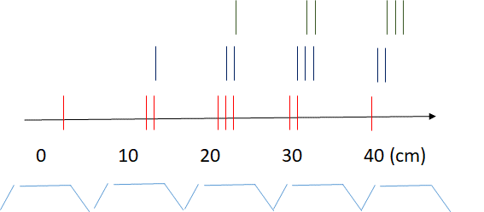

1. Sketch their spatial tuning curves with cm on the x-axis and firing rate on the y-axis
2. Now imagine you have an inhibitory synapse between neuron 1(red) and neuron 2(blue) as well as neuron 3 (green) and neuron 1. If this synapses is strong enough to overcome the neurons spiking response, sketch the resulting new tuning curve for neuron 2.
3. Now add an excitatory synapse from neuron 2 on itself and sketch the new resulting tuning curve.
4. Based on what you have learned about hippocampal cells, sketch the phase of spikes (without inhibition and excitation) with respect to an underlying theta oscillation (sketched in light blue).
5. If you used synchrony between neurons as your measure for where the rat is, could you define location and what would the ‘code ‘ look like (i.e. n1/2, n1/2, n1/2/3) and would the resolution be higher or lower than that using rates or phase ?
6. Using the receptive fields you sketched in (a), draw the phase diagrams of n2 as a function of n1.
7. What would an autocorrelation of neuron 1 with itself look like?
8. Review one or two concepts we learned you find particularly intriguning